

**DEBRE TABOR UNIVERSITY**

**DEPARTMENT OF COMPUTER SCIENCE**

**INTRODUCTION TO COMPUTER SCIENCE MODULE**

**For 2nd Year ________________Regular Students**

**COMPILED BY:-Computer Science and IT Instructors**

**May 2022**

**Chapter One**

**1.1 Introduction to computer**

Q. What is Computer science, computer, data and information?

**Definition:** Computer science or computing science is the study and the science of the theoretical foundations of information and computation and their implementation and application in computer systems. Computer science needs its own special devices as if chemistry has “test tube” for its practical aspect. This device is called **computer.**

The word computer generated from a Latin word “compute” which means, “to calculate” and can be applied to abacus or any adding machine as to the modern computer. A computer is any calculating device or machine, which is electrical, mechanical or electromechanical.

A **computer** is an electronic machine, operating under the control of instructions stored in its own memory that can accept data, manipulate the data according to specified rules, produce results, and store the results for future use. Computers **process** ***data*** to create information. **Data** is a collection of raw or unprocessed facts, figures, and symbols. **Information** is data that is organized, meaningful, and useful.

**Data**

**Information**

**System**

**Information**

Fig. 1.1 show how data is converted in to information

Why we need computer is that if we want some problems to be solved, in nowadays computers can solve problems if the problem can be solved in to logical steps. From these definitions, what a computer in general does is that:

* It takes input in various forms from different input units;
* Process it according to a given set of instructions called program;
* Produce an output in required form such as printed on paper or soft copy and gives it to the end users;
* Storage / keeps the results for future use and later processing and
* Controlling /coordinates all the activities inside the computer.

Input

(Raw data)

Processing

(+,*, /, - , sorting etc)

Output or processed data

(Information)

Storage

For later processing

For future use

Disseminating

Figure1.2. Basic functions of computers

**1.2 History and Generations of computer**

The history of computer development is often referred to the different generations of computing devices. Each generation of computer is characterized by a major technological development that fundamentally changed the way computers operate, resulting in increasingly smaller, cheaper, and more powerful, and more efficient and reliable devices. Therefore computers passes so many generations to

1. First Generation (1940-1956) Vacuum Tubes :

The first computers used vacuum tubes for circuitry and magnetic drums for memory, and were often enormous, taking up entire rooms. They were very expensive to operate and in addition to using a great deal of electricity, generated a lot of heat, which was often the cause of malfunctions.

1. Second Generation (1956-1963) Transistors:

Transistors replaced vacuum tubes and ushered in the second generation of computers. The transistor was far superior to the vacuum tube, allowing computers to become smaller, faster, cheaper, more energy-efficient and more reliable than their first-generation predecessors.

1. Third Generation (1964-1971) Integrated Circuits:

The development of the integrated circuit was the hallmark of the third generation of computers. Transistors were miniaturized and placed on silicon chips, called semiconductors, which drastically increased the speed and efficiency of computers.

1. Fourth Generation (1971-Present) Microprocessors:

The microprocessor brought the fourth generation of computers, as thousands of integrated circuits were built onto a single silicon chip. What in the first generation filled an entire room could now fit in the palm of the hand.

1. Fifth Generation (Present and Beyond) Artificial Intelligence :

Fifth generation computing devices, based on artificial intelligence , are still in development, though there are some applications, such as voice recognition , that are being used today. The use of parallel processing and superconductors is helping to make artificial intelligence a reality.

|  |  |  |  |  |  |
| --- | --- | --- | --- | --- | --- |
| **Features** | **Generations of computers** | | | | |
| **First** | **Second** | **Third** | **Fourth** | **Fifth** |
| **Circuit element** | Vacuum tubes | Transistors | IC (Integrated Circuit) | LIC (Large Scale Integrated Circuit) | VLSICs, UVICs, Bio & organic |
| **Secondary storage** | Punched cards & Magnetic drum | Magnetic tape | Magnetic disk | Mass storage devices | Most massive storage |
| **Operating system** | Primitive or operators control | Batch processing | Time sharing, Parallel processing, real-time | User-friendly | More user friendly |
| **Computer language** | Machine & assembly | COBOL, FORTRAN etc | Structured languages | Application oriented | Natural languages |
| **Size** | largest | larger | Medium | Smallest | The smallest |
| **Speed** | Slowest | Slower | Medium | Faster | The fastest |
| **Availability** | Obsolete | Obsolete | Obsolete | Current | future |
| **Reliability** | Unreliable | Less reliable | More reliable | Most reliable | Most |

Table 1.1 a comparative study of various computer generations

**1.3 Characteristics of computer**

The characteristics of computers that have made them so powerful and universally useful are speed, accuracy, diligence, versatility and storage capacity. Let us discuss them briefly.

1. **Speed**: - Computers work at an incredible speed. A powerful computer is capable of performing about 3-4 million simple instructions per second. Their speed is measured by the amount of time it took to perform or carry out a basic operation. Computer speed measured in terms of microsecond (10-6 one millionths), nanosecond (10-9 one billionths), and Pico second (10-12 one trillionths).
2. **Accuracy**: - ***Nowadays*** computers are being used for surgical purposes, which need almost a hundred percent accuracy. From this we can understand that computers are accurate and consistent. Unless there is an error in the input data or unreliable program the computer processes with a very high accuracy.
3. **Diligence:-** Unlike human beings, computers are highly consistent. They do not suffer from human traits of boredom and tiredness resulting in lack of concentration. Computers, therefore, are better than human beings in performing voluminous and repetitive jobs.
4. **Versatility:-**  Computers are versatile machines and are capable of performing any task as long as it can be broken down into a series of logical steps. The presence of computers can be seen in almost every sphere – Railway/Air reservation, Banks, Hotels, Weather forecasting and many more.
5. **Automatic:-** Once necessary information and program is fed, the computer performs processing without human intervention.
6. **Storage capacity:-** Today’s computers can store large volumes of data. A piece of information once recorded (or stored) in the computer, can never be forgotten and can be retrieved almost instantaneously. And the time it took to retrieve or process single information is not more than a micro or nanoseconds.

**In general** a computer has a capacity to store a very large amount of information in organized manner so that accessing information is very fast.

### 1.4 Types of Computers

Computers can be classified into different categories based on different characteristics.

* **Based on type of data they process**

Based on the type of data they process computers can be classified as:

***Analog:-*** Analog computers operate by measuring physical properties. They deal with continuous variables; they don’t compete directly with numbers, rather, they operate by measuring physical magnitude such as pressure, temperature, voltage, current etc.

**Examples**: Thermometer, Voltmeter, Speedometer

***Digital:-*** Digital computers deal with discrete variables; they operate by counting rather than measuring. They operate directly up on numbers (or digits) that represent numbers, letters, or other special symbols.

**Examples**: Abacus, Desk & pocket calculators, general purpose computers

**Hybrid:-** Hybrid computers inherit the best features of both analog and digital computers. Usually the Input is continuous data (analog). Since Digital Processing is more accurate, processing takes place digitally. The processed information – the output – could be either digital or analog, depending on the user preference or the type of application.

**Examples**: digital camera, health monitoring machines in some hospitals,

* **Based on Size, Capacity and price**

Size and capacity are also the other characteristics of computers that can be used to categorize computers. Based on these characteristics computers can be classified as:

**Super computer**

The term supercomputer has been coined to describe a category of extremely powerful computer designed for high-speed processing. A supercomputer is generally characterized as being the fastest, most powerful, and most expensive computer.

Generally, Supercomputers are:

* The largest and the most efficient computers
* Very expensive
* very fast and
* Supports hundreds of users at different locations

**Mainframe computer**

Mainframe computers are large, powerful computers that are physically larger than micros and minis and usually have processors with faster instruction processing speeds. For example, they may be able to process from 10 to 200 million instructions per second (MIPS). Mainframe computers also support multiple users and are expensive.

**Mini computer**

Minicomputers are midrange computers that are larger and more powerful than most microcomputers but are smaller and less powerful than mainframe computer systems. Minicomputers are being used for a large number of business and scientific applications. They are popularly used in scientific laboratories, research centers, universities and colleges, engineering firms, industrial process monitoring and control, etc.

**Micro computers**

The smallest computers ever produced in the history of computers are microcomputers. Since they are designed to be used by a single user, they have the least capacity as compared to the other types of computers. They are also the least expensive of all types. There two different types of microcomputers are desktop computers and portable computers (laptops, notebook computers and palmtops)

* **Classification by purpose of application**

Computers can be applied or used for different purposes. Based upon their application, they are classified as special purpose or general purpose computers.

**Special purpose computers**

They are designed to solve a single type of problem, that is their components and their functions are uniquely adapted to a specific situation involving specific application.

Example:

* The public telephone box
* Traffic control system
* Ticket machines (used in grocery, super market etc.)
* Pocket-calculators etc.
* Counters
* Most analog computers are special purpose computers.

**General purpose computers**

They are designed to solve variety of problems through the use of “store program concept”. A program or set of instructions designed to solve a problem is read and stored into the memory and then executed by the computer one by one. The same computer can be applied to solve another set of problem using different program. General computers are more flexible and versatile.

Examples

* Micro computers
* Mini computers
* Super computers etc.

**1.5 Limitation of computers**

Computers have the following limitations:-

1. Cannot decide how to be programmed
2. Does not provide its own inputs, unless people provide with the input
3. Interpretation of data and implementation of decision is left for human beings
4. Unlike human beings, computers are incapable to:

* Think Motivated and
* Create Judge

## 1.6 Application of Computers

* Discuss the application of computer in your field of study. (6 minutes)

Applications of computers differ from organization to organization or from individual to individual based on the specific needs of organizations and individuals. Sometimes applications may be associated with the size of the computer. For example, a supercomputer is not generally used for word processing activity. Supercomputers are used in scientific applications such as aerodynamics design, processing of geological data, and collecting and processing weather data, etc. Mainframe computers are used by large organizations to coordinate and manage vast amounts of data. They can be used by many businesses to update inventory, schedule production, keep employee records, generate sales and management reports, etc. Minicomputers are well adapted for functions such as accounting, word processing, database management, etc. Microcomputers are used in a variety of application. They are the most widely used computer types for business and personal purpose.

In general **microcomputers** are used for:

|  |  |
| --- | --- |
| - word processing,  - computerized worksheet analysis and modeling,  - education,  - record keeping, | - graphics,  - engineering activities and  - personal and home use etc. |

The main areas of computer applications are categorized in to:

1. ***Commercial or business applications***

- Emphasis on data processing.

-It involves the use of computers for clerical, administrative, production and business use.

**Example:** Text processing, accounting and finance management, inventory control, database management, statistical analysis etc.

1. ***Scientific, Engineering and Research applications***

- Emphasis on scientific processing.

-Using computers for scientific research, complex mathematical calculations, design work, and analysis of experimental data/results and control of physical systems.

**Examples:** space technology, meteorological observatory system, nuclear control system, astronomical investigations system etc. Let’s see some particular application areas of computers.

**Computers in education**

* For instruction and administration purpose.
* Can guide a user through a course of instruction.
* Can guide /provide instruction and ask questions of the user.
* CAE (Computer Assisted Education), online teaching, training, conferencing, and distance learning are good examples of computer applications in the fields of education.

**Computers in Medicine**

* Used as an aid to medical research by analyzing data produced from the trial of drugs.
* Used as an aid for diagnosis.
* Used to hold details of patients etc.

**Computers in manufacturing**

* Stock and production control
* Engineering design
* Design, manufacturing and testing processes are all in computerized.

**Chapter two**

**2.1 Organization of a computer system**

* Brainstorming: how the computer system components work together?

System is a composition or group of different integrated components that work together to achieve a common goal. A computer system also consists of two basic components such as computer hardware and computer software.

A typical computer system i.e. hardware consists of input, output, storage and the central processing unit (CPU). Each of these components is equally important to the functioning of the entire computer system. Most digital computers are designed based on **John Von Neumann architecture.**

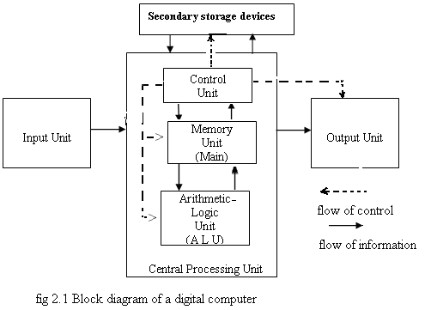

Generally, a computer system is composed of two main components:

1. Computer hardwareand
2. Computer software

**2.2 Computer Hardware**

Computer hardware is the physical part of the computer system that can be seen and felt. The hardware part of a computer system is composed of a number of interacted physical parts. E.g. keyboard, mouse, CPU

**Types of Computer Hardware**

The hardware part of a computer system is composed of a number of interacting physical parts based on the need of the information flow. Information flows in the computer hardware. There are several criteria by which computer hardware can be categorized.

Based on **information processing**, we can divide **computer hardware** into **four**:

1. Input Devices
2. Storage Devices
3. Output Devices
4. Central Processing Unit (CPU)

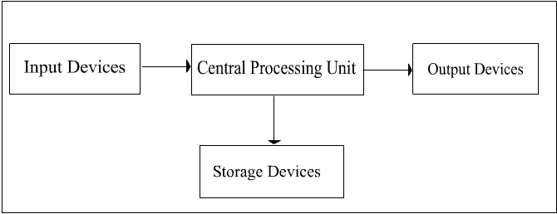

##### Input Devices

**Input devices** are used to **enter information** into **computer**. They **convert** the **data** we give them into the form that can be **manipulated** in the **computer** (**electronic format**).

Some examples of input devices are Keyboard, mouse, scanner**,** Bar Code Reader, mice

##### Central Processing Unit

**CPU** executes instructions and performs the computer's processing activities. It is also known as processor or microprocessor. It functions the same purpose as the human brain for human being. It is called the brain of the computer.

One of the basic features of a computer that affects its entire performance is the CPU speed. CPU speed is measured in Hertz (Hz). Hertz is the number of **cycles per second**. 1Hz=1cycle per second. Larger units are KHz (Kilo Hertz), MHz (Mega Hertz), GHz (Giga Hertz), etc.

1 KHz = 1000 Hz

1 MHz = 1000 KHz

1 GHz = 1000MHZ

Current CPUs are as fast as 2-3GHz (2-3 billion cycles per second)

**CPU has three sub-components:**

* Control Unit (CU)
* Arithmetic Logic Unit (ALU)
* Memory

**Control Unit**

As human brain controls the body, control unit controls the computer hardware. Control Unit does not execute instruction by itself, i.e. does not carry out instruction processing, but it directs other processing elements to execute instructions.

**Arithmetic Logic Unit (ALU)**

The purpose of ALU is to execute instruction. It performs two operations:

* Arithmetic operation
* Logic Operation

**Arithmetic operation***:* this includes mathematical operations like addition, subtraction, multiplication, division, etc. If you give your computer the instruction *2+3,* this will be included in arithmetic operation and it is executed by Arithmetic Unit.

**Logical Operation***:* this is concerned with the comparison of data and it is called logical operation. It includes operators like less than, greater than, equal to, less or equal to, greater or equal to, different from, etc. e.g. if mark>80, grade is 'A'.

#### Output Devices

Output devices are usedto get data out of a computer so that it can be examined, analyzed or distributed to others. It converts information from machine-understandable form to a human understandable form. The outputs are of two types: *Softcopy*: displayed on monitor, projector, or similar devices and *Hardcopy*: printed on paper

Examples

* The Visual Display Unit (VDU) or monitor or screen
* Printers
* Plotters
* Voice (audio) response unit
* Disk drives

#### Storage Devices

One of the unique features of computers is storage. Data can be stored on different storage media temporarily or permanently. Storage devices can be categorized into to as:

1. Primary storage device
2. Secondary storage device

**1. Primary Memory / Main Memory**

Primary memory, also called *Main memory*, refers to integrated circuit that stores program instructions and data. The CPU closely works with the main memory to perform its activities. Memory stores three things:

* Operation system software instructions
* Application software instruction
* Data that is being processed

Depending on the type of information they store and the technology used, the primary memory can be categorized into three:

* RAM (Random Access Memory)
* ROM (Read Only Memory)

**RAM** is temporary storage i.e. the data is lost when the computer is off unlike secondary storage. Because of this it is called volatile memory.

Why is it volatile? It uses electric power to store data. When you write anything on your computer, first it is stored on RAM. When you save the file, it is transferred into secondary storage.

RAM has differing capacity, the common ones being 128, 256, and 512.It is directly accessible by CPU. It is called RAM because each memory location can be accessed randomly using memory address. Each unit in RAM has memory address by which it can be easily accessed/referenced.

**ROM**stores data and programs that are permanently required by the computer. They have programs built into them at the factory and that program could not be changed or erased by the user, but read. It is non-volatile, read-only (not changeable) memory. Read-only means data can't be altered or erased but read.

**2. Secondary Storage**

Secondary storage (also called auxiliary storage) supplements the primary memory. It takes many forms. It includes punched cards, punched paper tape, magnetic tape, magnetic disk and optical disk. Based on information access, secondary storage devices are divided into two:

* **Sequential Access:** information is accessed sequentially. To access information on such media, we start from the beginning and read through to the end. Jumping to some part is not possible. E.g. tape recorder cassette
* **Random Access:** information can be accessed in any order. You can access the first or the last part of information by jumping others. E.g. floppy disk

### 2.3 Computer Software

Computer hardware is directed by a set of instructions. Without these instructions, computers can do nothing. These set of instructions are called software (also called programs). One or more programs are termed as **software**. We use programming languages to write these instructions. Examples of programming languages include C, C++, Visual Basic, Java, etc.

**Software** **is categorized into two**:

* System Software
* Application Software

#### *System Software*

System software consists of programs that are related to controlling the actual operations of the computer equipment/resource.

There are three types of system software:

* Operating System
* Utility Software
* Language translators

**Operating system** manage resources, provides a user interface, and run application software. It organizes resources such as keyboard, mouse, printer, monitor, etc. It also presents GUI (Graphical User Interface) to the user for easy use of computer. It makes complex hardware more users friendly i.e. it acts between the user and hardware.Operating system coordinates the activity between the user and the computer

**Utilities software is programs** that make computing easier. They perform specific tasks related to managing computer resources or files. Eg. Backup software, antivirus software

**Language translators** are used to **convert the programming instruction written by users into binary code** that the computer can understand. They are **written for specific** **programming languages** and **computer system**.

#### *Application Software*

**Application software** performs **useful work** for the **user**. These useful works could be:

* Word processing-document creation
* Spreadsheet-electronic calculation
* Data base system
* Email/communicating-email sending and reading

Users use this software to perform different activities like calculation, video editing, word processing, presentation, etc.

**CHAPTER 3**

**3.1 DATA REPRESENTATION IN COMPUTER SYSTEM**

**Data Representation**

Every computer stores numbers, letters, & other special characters in a coded form. But a computer stores those data’s in a binary number system. There are two main code forms that every number, letter and special character is represented in a computer system. Before discussing those codes let have a look at binary number system.

**3.2 The Binary Number System**

Computers are electronic devices that use electrical patterns to represent numbers. Modern digital computers recognize only two electrical states—ON and OFF— but their memories contain millions of transistors that can be either on or off. Working with numbers in computers is like making numbers out of a row of lights that can be switched on and off independently. Because there are only two ways to represent a number, computers use the binary number system (base 2 or radix 2).

**A relationship among Binary & other number system**

**Decimal** **Hexadecimal** **Octal** **Binary**

0 0 0 0

1 1 1 1

2 2 2 10

3 3 3 11

4 4 4 100

5 5 5 101

6 6 6 110

7 7 7 111

8 8 10 1000

9 9 11 1001

10 A 12 1010

11 B 13 1011

12 C 14 1100

13 D 15 1101

14 E 16 1110

15 F 17 1111

16 10 20 0001 0000

### Why Binary?

Why do we go for binary numbers instead of decimal numbers?’ The reasons are as follows:

1. The 1st reason is that the **electronic & electrical components, by their very nature, operate in a binary mode.** Information is handled in the computer by electronic/electrical components such as transistors, semiconductors, wires, etc all of which can only indicate 2 states or conditions – on(1) or off(0).

Transistors are either conducting (1) or non conducting (0); a voltage is present (1) or absent (0) in wire. The binary number system, which has only two digits (0&1), is most suitable for expressing the two possible states

1. The second reason is that the **computer circuits only have to handle two binary digits** rather than ten decimal digits. This greatly simplifies the internal circuit design of computers, resulting in less expensive & more reliable circuits.
2. Finally, the binary system is used because everything that can be done in decimal number system (**addition, subtraction, division & multiplication**) can also be done in binary number system.

## Units of Data Representation

When data is stored, processed, or communicated within the computer system, it is “packed” in units. Arranged from the smallest to the largest, the units are called bits, bytes, & words.

**Bits, Bytes and Words**

**Bits**

A ***bi****t* is a single binary digit. A bit may have a value of 0 or 1. In a computer, a switch or transistor that is **off** represents a **0**, and a switch or transistor that is **on** represents a **1**. A bit is represented by the numbers 1, & 0, which correspond to the states **on & off, true & false, or yes & no.**

**Bytes**

Most computers work with groups of **8 bits**, which is called **a *byte*.** To make it easier to read, the 8 binary digits in a byte are divided into two groups of four, called *nibbles*, when they are written.

One byte may hold binary numbers ranging in value from 0000 0000 (base 2) to 1111 1111 (base 2), or from 0 (base 10) to 255 (base 10). Counting 0 as a value, one byte can contain 256 values. For many computer variables, the maximum value is 255 because the computer wants to store the value in a single byte, or you are limited to 256 choices.

**Words**

* Bytes are combined into groups of 1 to 8 bytes called words.
* Words refer to the number of bits that a computer process at once.
* Typically word lengths are 8 bits, 16 bits, 32 bits & 64 bits.

**Computer Number systems**

A decimal integer is converted to any other base, by using the division operation.

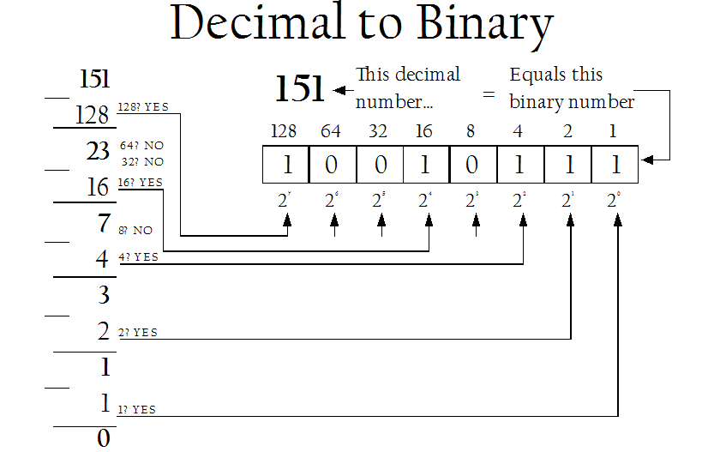

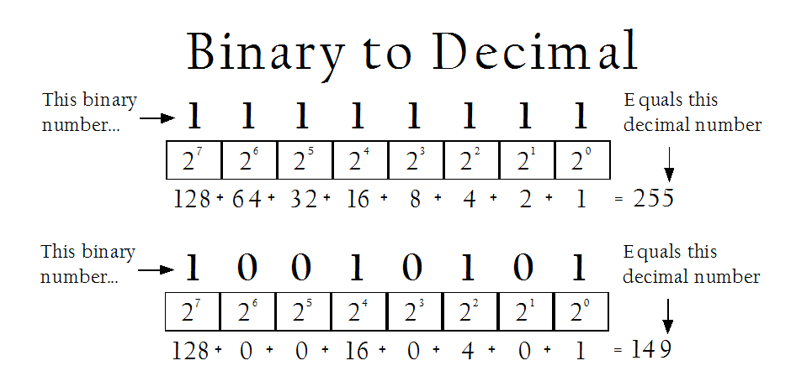

**Hexadecimal number system**

* Computers use hexadecimal because it represents binary values in a compact form.
* Base 16 number system
* *Hex* means six, *Deci* means ten
* 16 symbols are used - 0 thru 9, A, B, C, D, E, F
  + 0-9 = 0-9
  + A = 10 D = 13
  + B = 11 E = 14
  + C = 12 F = 15

**Conversion of decimal to hexadecimal**

* + Reverse the process
  + 59 is 3B in hexadecimal
  + 16 goes into 59 three times
  + It will take “11” or “B” to get to 59 (59 = 3*16+11) =3 * B (11)

**Example: Convert the decimal number 90 into hexadecimal number**

Solution:

**90 = (5 * 16) +10 this implies 5A because the number 10 is represented by A in hexadecimal.**

**90 dividing by 16 and collecting the remainder of the digit we can verify it.**

* A binary number can be converted into
* octal or hexadecimal number using a shortcut method. The shortcut method is based on the following information:-
* An octal digit from 0 to 7 can be represented as a combination ***of 3 bits***, since 23 = 8.
* A hexadecimal digit from 0 to 15 can be represented as a combination ***of 4 bits,*** since 24 = 16.

## Decimal to Other Base System

Steps

* **Steps 1** - Divide the decimal number to be converted by the value of the new base.
* **Step 2** - Get the remainder from Step 1 as the rightmost digit (least significant digit) of new base number.
* **Step 3** - Divide the quotient of the previous divide by the new base.
* **Step 4** - Record the remainder from Step 3 as the next digit (to the left) of the new base number.

Repeat Steps 3 and 4, getting remainders from right to left, until the quotient becomes zero in Step 3.

The last remainder thus obtained will be the most significant digit (MSD) of the new base number.

### Example

Decimal Number: 2910

Calculating Binary Equivalent:

|  |  |  |  |
| --- | --- | --- | --- |
| **Step** | **Operation** | **Result** | **Remainder** |
| Step 1 | 29 / 2 | 14 | 1 |
| Step 2 | 14 / 2 | 7 | 0 |
| Step 3 | 7 / 2 | 3 | 1 |
| Step 4 | 3 / 2 | 1 | 1 |
| Step 5 | 1 / 2 | 0 | 1 |

As mentioned in Steps 2 and 4, the remainders have to be arranged in the reverse order so that the first remainder becomes the least significant digit (LSD) and the last remainder becomes the most significant digit (MSD).

Decimal Number: 2910 = Binary Number: 111012.

## Other base system to Decimal System

Steps

* **Steps 1** - Determine the column (positional) value of each digit (this depends on the position of the digit and the base of the number system).
* **Step 2** - Multiply the obtained column values (in Step 1) by the digits in the corresponding columns.
* **Step 3** - Sum the products calculated in Step 2. The total is the equivalent value in decimal.

### Example

Binary Number: 111012

Calculating Decimal Equivalent:

|  |  |  |
| --- | --- | --- |
| **Step** | **Binary Number** | **Decimal Number** |
| Step 1 | 111012 | ((1 x 24) + (1 x 23) + (1 x 22) + (0 x 21) + (1 x 20))10 |
| Step 2 | 111012 | (16 + 8 + 4 + 0 + 1)10 |
| Step 3 | 111012 | 2910 |

Binary Number: 111012 = Decimal Number: 2910

## Other Base System to Non-Decimal System

Steps

* **Steps 1** - Convert the original number to a decimal number (base 10).
* **Step 2** - Convert the decimal number so obtained to the new base number.

### Example

Octal Number: 258

Calculating Binary Equivalent:

### Step 1: Convert to Decimal

|  |  |  |
| --- | --- | --- |
| **Step** | **Octal Number** | **Decimal Number** |
| Step 1 | 258 | ((2 x 81) + (5 x 80))10 |
| Step 2 | 258 | (16 + 5 )10 |
| Step 3 | 258 | 2110 |

Octal Number: 258 = Decimal Number: 2110

### Step 2: Convert Decimal to Binary

|  |  |  |  |
| --- | --- | --- | --- |
| **Step** | **Operation** | **Result** | **Remainder** |
| Step 1 | 21 / 2 | 10 | 1 |
| Step 2 | 10 / 2 | 5 | 0 |
| Step 3 | 5 / 2 | 2 | 1 |
| Step 4 | 2 / 2 | 1 | 0 |
| Step 5 | 1 / 2 | 0 | 1 |

Decimal Number: 2110 = Binary Number: 101012

Octal Number: 258 = Binary Number: 101012

## Binary to Octal

An easy way to convert from binary to octal is to group binary digits into sets of three, starting with the least significant (rightmost) digits.

|  |  |  |
| --- | --- | --- |
| Binary: 11100101 = | 11 100 101 |  |
|  | 011 100 101 | Pad the most significant digits with zeros if necessary to complete a group of three. |

Then, look up each group in a table:

|  |  |  |  |  |  |  |  |  |
| --- | --- | --- | --- | --- | --- | --- | --- | --- |
| Binary: | 000 | 001 | 010 | 011 | 100 | 101 | 110 | 111 |
| Octal: | 0 | 1 | 2 | 3 | 4 | 5 | 6 | 7 |

|  |  |  |  |  |
| --- | --- | --- | --- | --- |
| Binary = | 011 | 100 | 101 |  |
| Octal  = | 3 | 4 | 5 | = 345 oct |
|  |  |  |  |  |

## Binary to Hexadecimal

An equally easy way to convert from binary to hexadecimal is to group binary digits into sets of four, starting with the least significant (rightmost) digits.

Binary: 11100101 = 1110 0101

Then, look up each group in a table:

|  |  |  |  |  |  |  |  |  |
| --- | --- | --- | --- | --- | --- | --- | --- | --- |
| Binary: | 0000 | 0001 | 0010 | 0011 | 0100 | 0101 | 0110 | 0111 |
| Hexadecimal: | 0 | 1 | 2 | 3 | 4 | 5 | 6 | 7 |

|  |  |  |  |  |  |  |  |  |
| --- | --- | --- | --- | --- | --- | --- | --- | --- |
| Binary: | 1000 | 1001 | 1010 | 1011 | 1100 | 1101 | 1110 | 1111 |
| Hexadecimal: | 8 | 9 | A | B | C | D | E | F |

|  |  |  |  |
| --- | --- | --- | --- |
| Binary = | 1110 | 0101 |  |
| Hexadecimal = | E | 5 | = E5 hex |

**Example**

Convert the following binary numbers into decimal numbers.

* Conversion of binary number 1010101000010111to hexadecimal number is - AA1716

## Octal to Hexadecimal

When converting from octal to hexadecimal, it is often easier to first convert the octal number into binary and then from binary into hexadecimal. For example, to convert 345 octal into hex:

(From the previous example)

|  |  |  |  |  |
| --- | --- | --- | --- | --- |
| Octal  = | 3 | 4 | 5 |  |
| Binary = | 011 | 100 | 101 | = 011100101 binary |

Drop any leading zeros or pad with leading zeros to get groups of four binary digits (bits):  
Binary 011100101 = 1110 0101

Then, look up the groups in a table to convert to hexadecimal digits.

|  |  |  |  |  |  |  |  |  |
| --- | --- | --- | --- | --- | --- | --- | --- | --- |
| Binary: | 0000 | 0001 | 0010 | 0011 | 0100 | 0101 | 0110 | 0111 |
| Hexadecimal: | 0 | 1 | 2 | 3 | 4 | 5 | 6 | 7 |

|  |  |  |  |  |  |  |  |  |
| --- | --- | --- | --- | --- | --- | --- | --- | --- |
| Binary: | 1000 | 1001 | 1010 | 1011 | 1100 | 1101 | 1110 | 1111 |
| Hexadecimal: | 8 | 9 | A | B | C | D | E | F |

|  |  |  |  |
| --- | --- | --- | --- |
| Binary = | 1110 | 0101 |  |
| Hexadecimal = | E | 5 | = E5 hex |

Therefore, through a two-step conversion process, octal 345 equals binary 011100101 equals hexadecimal E5.

## Hexadecimal to Octal

When converting from hexadecimal to octal, it is often easier to first convert the hexadecimal number into binary and then from binary into octal. For example, to convert A2DE hex into octal:

(From the previous example)

|  |  |  |  |  |  |
| --- | --- | --- | --- | --- | --- |
| Hexadecimal = | A | 2 | D | E |  |
| Binary = | 1010 | 0010 | 1101 | 1110 | = 1010001011011110 binary |

Add leading zeros or remove leading zeros to group into sets of three binary digits.

Binary: 1010001011011110 = 001 010 001 011 011 110

Then, look up each group in a table:

|  |  |  |  |  |  |  |  |  |
| --- | --- | --- | --- | --- | --- | --- | --- | --- |
| Binary: | 000 | 001 | 010 | 011 | 100 | 101 | 110 | 111 |
| Octal: | 0 | 1 | 2 | 3 | 4 | 5 | 6 | 7 |

|  |  |  |  |  |  |  |  |
| --- | --- | --- | --- | --- | --- | --- | --- |
| Binary = | 001 | 010 | 001 | 011 | 011 | 110 |  |
| Octal = | 1 | 2 | 1 | 3 | 3 | 6 | = 121336 octal |

Therefore, through a two-step conversion process, hexadecimal A2DE equals binary 1010001011011110 equals octal 121336.

## Hexadecimal to Decimal

Converting hexadecimal to decimal can be performed in the conventional mathematical way, by showing each digit place as an increasing power of 16. Of course, hexadecimal letter values need to be converted to decimal values before performing the math.

|  |  |  |  |  |  |  |  |  |
| --- | --- | --- | --- | --- | --- | --- | --- | --- |
| Hexadecimal: | 0 | 1 | 2 | 3 | 4 | 5 | 6 | 7 |
| Decimal: | 0 | 1 | 2 | 3 | 4 | 5 | 6 | 7 |
| Hexadecimal: | 8 | 9 | A | B | C | D | E | F |
| Decimal: | 8 | 9 | 10 | 11 | 12 | 13 | 14 | 15 |

A2DE hexadecimal:  
= ((A) * 163) + (2 * 162) + ((D) * 161) + ((E) * 160)  
= (10 * 163) + (2 * 162) + (13 * 161) + (14 * 160)  
= (10 * 4096) + (2 * 256) + (13 * 16) + (14 * 1)  
= 40960 + 512 + 208 + 14  
= 41694 decimal

## Decimal to Hexadecimal

Here is an example of using repeated division to convert 1792 decimal to hexadecimal:

|  |  |  |  |  |
| --- | --- | --- | --- | --- |
| **Decimal Number** | **Operation** | **Quotient** | **Remainder** | **Hexadecimal Result** |
| 1792 | ÷ 16 = | 112 | 0 | 0 |
| 112 | ÷ 16 = | 7 | 0 | 00 |
| 7 | ÷ 16 = | 0 | 7 | 700 |
| 0 | Done. |  |  |  |  |

The only addition to the algorithm when converting from decimal to hexadecimal is that a table must be used to obtain the hexadecimal digit if the remainder is greater than decimal 9.

|  |  |  |  |  |  |  |  |  |
| --- | --- | --- | --- | --- | --- | --- | --- | --- |
| Decimal: | 0 | 1 | 2 | 3 | 4 | 5 | 6 | 7 |
| Hexadecimal: | 0 | 1 | 2 | 3 | 4 | 5 | 6 | 7 |

|  |  |  |  |  |  |  |  |  |
| --- | --- | --- | --- | --- | --- | --- | --- | --- |
| Decimal: | 8 | 9 | 10 | 11 | 12 | 13 | 14 | 15 |
| Hexadecimal: | 8 | 9 | A | B | C | D | E | F |

**CHAPTER 4: DATA COMMUNICATION AND COMPUTER NETWORKING**

**4.1 DATA COMMUNICATION**

**Communication** is a process of sharing ideas, information and messages with others in particular time and space. It includes writing, talking and non verbal communication like facial expressions, visual communications, electronic communications, etc.

Communication is also the transfer of information from one place to another. It may be manual – one person talks to another. Or it may be mechanical or electronic gadget or device. Whatever the case, the process of communication involves the following **basic components:**

**Source**- Generates data to be transmitted

**Message** -Information/data to be transmitted

**Transmitter**- Converts data into transmittable signals

**Transmission System**- A communication Equipment (intermediate device) that carries data

**Receiver**-Converts received signal into data

**Destination**-Takes incoming data

**Protocol**-Rules and standardsthat govern data communication

Let’s see how they work in a networked environment.

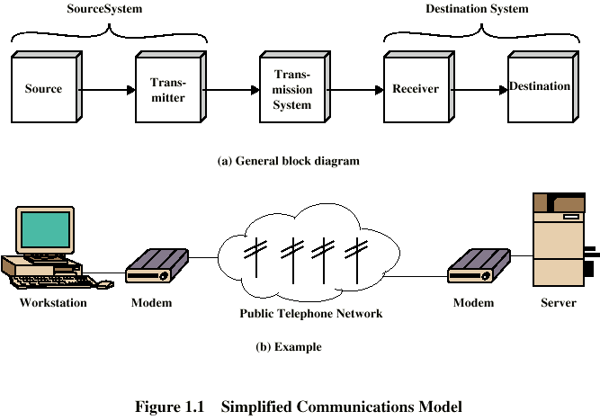

***4.2 Data Transmission Channels***

A channel is a medium that carries a signal from the transmitter to the receiver. The range of frequencies that can be transmitted over a transmission medium is called **bandwidth of a channel**. The rate of data transmission is directly proportional to the bandwidth.

**There are three types of data transmission channels**:-

A/ **Narrow-band**: - It is the smaller band and has slow data transmission rate.

Example: Telegraph line

B/ **Voice- -band**: - It is the wider band and has better data transmission rate than the narrow band. Example, Telephone lines are used for voice-band channel.

C/ **Broad-band**: - It is the widest band has used to transmit large volume of data with high speed. Example: (Oxide cable such as TV aerial lead), circuits, satellite communication and optical fibers are used for broad band channels.

***4.3 Mode of transmission***

The transmission medium may be physical (it connects the transmitter and receivers through wire) or logical (there are different mode of transmission).

**Simplex transmission**: - In this transmission, signals are transmitted in only one direction: One station is transmitter and the other is receiver.

Simplex channels are not often used because it is not possible to send back error(s) or control signals to transmitter end. Computers rarely use this mode transmission as a receiver cannot send an acknowledgement signals.

Eg. TV, Radio transmission, door bell etc

**Half-duplex transmission**: - Transmission is possible in both directions but only one way at a time i.e. both stations may transmit, but only one at a time. It is possible to perform error detection and request the sender to retransmit information that arrived corrupted. A common situation is for device **A**, acting as transmitter, to send a series of characters to device **B,** acting as receiver. Then **A** and **B** simultaneously switch roles and **B** sends acknowledgement.

Eg. Police radio (wacky talky) or talk back radio

**Full-duplex transmission**: - In this transmission, signals transmitted in both direction, both stations may transmit simultaneously. The medium carries signals in both directions at the same time.

Eg. Telephone

Modes of Data Transmission summary:

**Simplex**

Receiver

Sender

Sender or Receiver

Sender or Receiver

**Half Duplex**

Sender or Receiver

Sender or Receiver

Full Duplex

**4.2 NETWORK AND INTERNET**

**4.2.1 NETWORK – AN INTRODUCTION**

A **Network** is a system of interconnected computers that can communicate with one another. The technique of Communication through computer is called **Networking.** Networks allow users to share peripheral devices (peripheral devices are nothing but input – output devices connected to the computer), program and data. A Network need not be only of interconnected computers but, even interconnected telephone or any communication device that can communicate to each other and share the existing resources.

Many computer Networks are served by a host computer (or simply host) called Server. A **“Server”** is a computer shared by several users in a network. A **“Node”** is a device that is attached to a network. A node may be a microcomputer through which a user can communicate with the server and share the resources. A node may also be resources like storage device or any peripheral device.

There are also computer networks connected as **Peer – to – Peer**. The word **Peer** denotes - one who is equal in standing with another. This type of Network does not have any computer as Server or Node. Microcomputers in a peer-to-peer network, communicated directly with one another without relying on a server.

**4.2.1.1 Advantages of Networks**

**a) Sharing of peripheral devices:** Laser Printers, Hard disk drives and Scanners are examples of peripheral devices. All these devices cannot be connected to each and every computer as they are very expensive. Hence, these devices can be shared by many users through a network.

**b) Sharing of Programs and data:** In many organizations, people use almost the same software and access the same data. If these software and data were made available for individual users separately, then it is wastage of memory. Hence, by sharing the software and data the usage of memory can be minimized, thereby minimizing the expense.

**c) Better Communication:** In the digital world, information can be transferred within fraction of a second over long distances. And one of the greatest features of networks is Electronic Mail (E-Mail) system. Thus, a company can eliminate the delays encountered with standard postal services or with telephone tag, by using E-Mail services.

**d) Security of information:** Before networks became a common place, an individual employee was storing information in his or her desktop computer which was not secured. But today, such data or information could be backed-up or duplicated on a network storage device, shared by others.

**4.2.1.2 Types of Network**

Based on the size and the geographical areas, the Networks are classified into three types:

1. Local Area Networks (LAN)
2. Metropolitan Area Network (MAN)
3. Wide Area Network (WAN)

a) **Local Area Network** very popularly called as **LAN** and is a privately owned network that serves users within a single building as an office, or a group of buildings close together as a college campus. LANs are distinguished from other kinds of networks by three characteristics

1. Size
2. Transmission technology
3. Topology.

b) **Metropolitan Area Network,** very popularly called as **MAN** is a communication network covering a large geographic area when compared to LAN, like a city or suburb. A MAN can support both data and voice, and might even be related to the local cable television network. Cellular phone systems are also those systems that come under this type of Network. A MAN is basically bigger version of a LAN covering a group of nearby corporate offices in a city and might be either private or public.

c) **Wide Area Network,** very popularly called as **WAN** is communication Network spanning a huge geographical area like a state, country or a continent. It contains a collection of machines intended for running user (i.e., application) programs. The Internet links together hundreds of computer

***Generally***

***: WAN (Wide Area Network)***

* + - * No geographical limit
      * Can connect computers and other devices in different parts of the world
      * Examples:
        + A corporation with offices in London & New York
        + The Internet

Note: Whatever the type of the Network, they have the following components and features in common:

* + **Servers:** Computers that provide shared resources to the Network users.
  + **Clients:** Computers that access shared resources provided by servers.
  + **Media:** The way in which computers are connected.
  + **Resources:** files, printers or other items to be used by network u

**4.2.1.3 Network Topology**

Networks can be laid out in different ways. The Physical layout or shape of a Network is called Topology.

The term network topology refers to the shape of how the computers and other network components are connected to each other. It is the arrangement or physical layout of computers, cables, and other components on the network. Topology also determines how computers communicate on the network.

The different network topologies are:

1. Star topology
2. Bus topology
3. Ring topology
4. Mesh topology.
5. Tree Topology

a) A **Star topology** is one in which all microcomputers and other communication devices (nodes) are connected to a central hub, such as a Server or a Host computer via cables. This creates a fault tolerant system, that is able to survive if one or two of the workstations develops a bad link. But just like any system, a topology is only as strong as its weakest link. If the central hub or server malfunctions, the entire network fails. The advantage of a star topology is that, if a connection fails, the rest of the devices on the network will continue to operate. The disadvantage of a star topology is that the information is centralized.

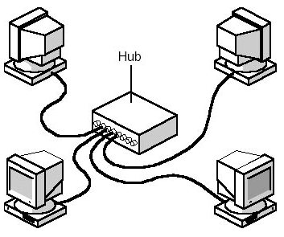

b) The **Bus topology** is the simplest of the network configurations. The development of computer system architecture, give rise to the concept of a bus, or highway approach to information transfer. It requires less cable than any other topology. In Bus topology all microcomputers and devices are connected through a common channel using co-axial cables. This layout forces every signal to be equally available to every device; thus, high traffic use will cause the network to slow. In this topology, if any connection to the node fails the entire network fails.

c) A **Ring topology** is the one in which all microcomputers and other communication devices are connected in a continuous loop. Electronic messages are passed around the ring in one direction, with each node serving as the repeater, until they reach the right destination. Since, all messages are flowing in only one direction; failure of a single node can compromise the entire network.

Computer

Computer

Computer

Computer

Computer

d) **Mesh topology**: As shown in the figure below ***mesh topology is*** a completely connected network that has a separate physical link for connecting each node to any other node. Thus, each computer of such network has a direct dedicated link, called a point-to-point link with all other computers of the network. The control is distributed with each computer deciding its communication priorities.

* 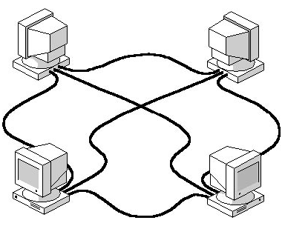Mesh networks are *fully-interconnected*, i.e. every node has a link to every other node
* Number of links ***L = N*(N-1)/2***
* Expensive to build/install, not feasible for large networks
* Fast communication between node

Fig. Mesh topology

e) **Tree Topology**

A tree topology can be thought of as being a “star of stars” network. In a tree network, each device is connected to its own central node or host in the same manner as in a star topology. However, hosts are connected together in a hierarchal manner.

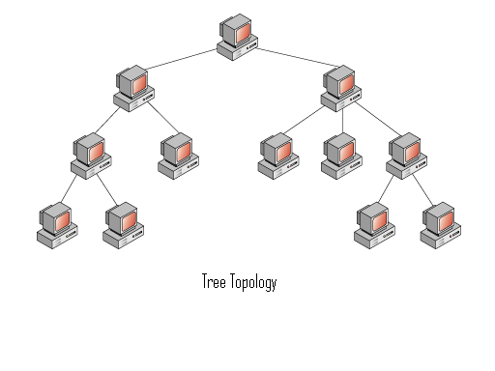

**4.2.2 INTERNET**

Internet or simply “the Net” is an international network connecting more than 140,000 smaller networks in more than 170 countries. These networks are formed by educational, commercial, nonprofit, government and military organization. On a given day 163 million computers in 200 countries get connected to the Internet.

**4.2.2.1. What is Internet?**

The term Internet has been coined from two terms, Interconnection and Network.

A Network is simply a group of computers that are connected together for sharing information and resources. Several such networks have been joined together across the globe to form what is called as the Internet? Thus, Internet is nothing but a Network of networks.

There is no single, generally agreed-upon answer to the question because the Internet is different for each of us:

* It is a set of computers talking over fiber optics, phone lines, satellite links, and other media.
* It is a place where you can talk to your friends and family around the world.
* It is a place to get cool game demos.
* It is an ocean of resources waiting to be mined.
* It is a place to do research for your thesis or a business presentation.
* It is unlimited commercial opportunity.
* It is a worldwide support group for any problem or need.
* It is a gold mine of professionals in all fields sharing information about their work.
* It is hundreds of libraries and archives that are open to your fingertips.
* It is the ultimate time-waster.
* It is the technology of the future that will help make our lives, and those of our children, brighter.

**4.2.2.2 History of Internet**

* In 1969, the U.S. Defense department built the Internet under the name ARPAnet (ARPA – Advanced Research Project Agency) to serve two purposes.
  + The first was to share research among military, industry and university sources.
  + The second was to provide a system for establishing communication among military units in the event of a nuclear attack.
* Soon after, other private networks came up following the design of ARPAnet.
* In 1998 the NSF (National Science Foundation) created NSFnet a network with FIVE super computers as a help to establish effective communication amongst universities.
* Although the Internet was originally meant for research purposes, it has now changed drastically and is mainly used for commercial purposes.
* Although there are organizations that help to manage different parts of the network, but there is no single body that owns the Internet.

**4.2.2.3. Who Owns Internet?**

No single entity owns the Internet. Any single person, service, corporation, university, or government does not fund it. Every person who makes a connection, every group who’s Local Area Network (LAN) becomes connected, owns a slice of the Internet. Because we have grown used to the model of centralized, cooperative utilities, such as the phone companies and the electric companies, we can comfortably compare the Internet to a utility.

The owner of the connected equipment therefore “owns” a piece of the Internet. The telephone companies “own” the pieces that carry the packets (blocks of information). The service providers “own” the packet routing equipment. So, while no one person or entity owns the Internet, all who use it or supply materials for it play a part in its existence.

**4.2.2.4. Internet Protocols**

Protocolsare the rules that the networks all use to understand each other. The various protocols are sets of technical specifications that let computers exchange information, no matter what kind of computers they are, or what kind of technology hooks them together. Ventures of software and hardware want their products to be useful on the Internet, and so they make sure those products understand the Internet protocols and operate within them. The term interoperability has been coined to describe the ability of disparate type of hardware and software to work together under a common set of rules. Interoperability is a hot market commodity today, and so you’ll see the term in the advertising and product reviews for all kinds of computer products. These connected networks usually use the **TCP/IP (Transmission Control Protocol/Internet Protocol)** communications suite. TCP/IP and the various protocols that are used on the Internet are important underlying concepts for the Net.

**4.2.2.5. Applications of Internet**

As rightly mentioned earlier the Internet was originally meant for research purposes, and now it has drastically changed for commercial purposes. Due to this drastical change the applications of Internet are increasing day by day. Following are the few applications of Internet.

**a) Accessing and obtaining Information.**

The faster growing part of the Internet is the World Wide Web (WWW). The World Wide Web or simply the Web consists of an interconnected system of sites called Websites. To access a website, web browser software like Microsoft’s Internet Explorer or Netscape Navigator has to be used. It is very difficult to conceive how much information is available on the web. Any information can be obtained from the web, say for example, about travel agent, financial investment groups, restaurant guides, mail-order shopping sites,……… etc. Online versions of newspapers and magazines are also available. How to search and find such information?

By using Web search engines information of interest can be obtained. Search engines are nothing but tools to search and find information from the web. These search engines are software called “Spiders” to crawl around the Web for searching information. Examples of some popular search engines are

* Alta vista
* Info seek
* Yahoo
* Google

**b) Communication**

The World Wide Web is getting all the headlines, but for many people the main attraction of Internet is the Electronic Main or E-Mail – the fastest way of sending messages from one user to another. It hardly takes few fractions of a second to transfer a message. There are several websites offering this service. For example,

yahoo.com

hotmail.com

rediffmail.com

freemail.com

**c) Marketing and Business on the Web**

Many people are now putting their business online. To do this, one needs to develop a website with online order forms. This concept is developing very fast day by day. Of course, it costs money to make more money.

**4.3. Hardware Requirements for Networks**

In most (Wide Area) Networks, the subnet consists of two distinct components:

* Transmission lines
* Routing Elements

**Transmission lines** (also called circuits, channels, or trunks) move bits between machines.

The (**Routing Elements**) **Switching Elements** are specialized computers used to connect two or more transmission lines. When data arrive on an incoming line, the switching element must choose an outgoing line to forward them on. Unfortunately, there is no interchangeable, especially when discussing hardware on a client/server network. You may notice that the term client can also refer to software or applications.

**Network medium**

Network medium is the general term used to describe all of the cabling and other materials that can be used to connect a network. The most common network medium is cabling. Dozens of cable types are available, but only four are in widespread use:

♦ Coaxial Cables

♦ Fiber-Optic

♦ STP (Shielded Twisted-Pair)

♦ UTP (Unshielded Twisted-Pair)

But networks are not limited to physical cabling; many wireless media are used as well. These include Infrared and Laser devices, radio and cellular connections, microwave antennas, and digital satellites. These media may increase the range of a network, and are often much more expensive than their physical counterparts, and are susceptible to more types of interference.

**Network Interface Card (NIC)**

* A NIC is the expansion card that is added to a computer to enable it to communicate on a network. The NIC translates the signals from the network into a form the computer can understand and vice versa for outgoing data.
* The NIC connects a computer with the network medium. A NIC can be a standard expansion card, a PCMCIA card, or even an external device connected through a communications port (such as a serial or parallel port).
* NIC usually have a memory buffer where information is temporarily stored and is transmitted to or from the network. This buffer enables the NIC to handle information bursting and chunking without bogging down the attached computer.

**Modem**

Modems are the devices used to communicate data over telephone lines. Modems get their name from their function, Modulation-Demodulation. This function is the translation of digital computer data into a signal that can be transmitted over a phone line and vice versa. Similar to a NIC, modems enable computers to communicate over the connection medium of the telephone system. Networks can be created using modems instead of NICs, but, more often, they are used to provide temporary connections for remote users.

**Hubs**

Hubs are also called as concentrators. They are network devices that are used to connect multiple network connections into more manageable configurations. The benefits of hub include the following:

♦ Simplification of cabling

♦ Increased reliability

♦ Trouble shooting is simplified for communication problems.

Server

Hub

Nodes

Hubs can either be simply cable connecting devices or intelligent hubs. Intelligent hubs can perform additional tasks, such a fault tolerance, remote management, and re-broadcasting. The term repeater refers to an intelligent hub that can re-send or repeat garbled data.

**Bridges, Routers, and Gateways**

Bridges, routers, and gateways are devices that enable one network to communicate or connect with another network. These specialized devices are required to link networks that use different connection media, NOS, or platforms. They are also used to link networks located at different locations, whether in the same building, city, country, or planet.

**CHAPTER – 5**

**COMPUTER SAFETY AND SECURITY**

**Threats of a computer System**

Threat is a source of probable trouble or attack to a system that could cause losses. One of the threats in computer system is Virus.

**Computer Viruses**

Computer viruses are software programs that are able to reproduce themselves. It is the intellectual creation of a human computer programmer. If a program is not able to replicate, then it is not a virus. Most computer viruses are damaging. Computer virus is a program that is **intentionally** done to **harm users’ program without permission**.

Not all viruses are destructive, some viruses carry messages of goodwill without harming programs or data.

Dangers of computer viruses

1. ***Change***: computer viruses can change actual data or text causing different sense
2. ***Slackness***: many viruses cause slow computing operation because of the load that their reproductive activity imposes.
3. ***Theft***: viruses can steal data, and stolen data can be used to re-steal other more data
4. ***Scramble (mix)***: virus can scramble data and files

There are three major types of viruses.

1. Boot sector viruses
2. File infectors
3. Macro viruses
4. System infectors

***Boot sector viruses***

Boot sector viruses attach themselves to the system code and **hides behind the boot sector of hard disk**

***File infectors/program infectors***

These viruses **attach themselves** to ***executable files or programs***. Therefore, file infectors affect **system performance**. These viruses are the most widely spread viruses as executable files or programs run

***Macro viruses***

The latest virus threat comes from macro viruses. Macro viruses are hosted in **user documents.**

The result of a macro virus infection can be just as **destructive**. Macro viruses represent a **larger threat as they attack data files** rather than executables. Although executable files can be easily replaced by reinstalling the affected software, **documents are irreplaceable** ***unless they have been backed up onto other media***.

***System infectors***

Attach themselves to the specific system files. E.g. **command.com**, etc

**Potential Paths for Virus**

Viruses are transmitted through various media such as:

* Storage devices. E.g. ***Hard disk, floppy disk, flash disk, CD-ROM***
* Internet connection- ***e-mail attachments, sharing infected files***
* Direct cabling between PCs (**network**). etc

**Rules for safe computing**

These simple rules will protect /secure/ your system from computer virus infection

1. Never load unknown disks into system unless the disks are virus free
2. Do not use infected software (executable files) unless they are free of virus infection
3. Backup your data regularly to protect the data loss from any cause
4. Prevent unauthorized access
5. Lock your computer when not in use
6. Install antivirus program on to your computer and update regularly/configure to update itself automatically if there is internet connection

**Safety of the computer system**

Computers require uniform and uninterrupted power supply, no noise interference and suitable environmental conditions for reliable operation.

**Power line problem/disturbances**

The power disturbances, which are common occurrences in AC utility line, may have no effect in most electrical equipment, but they can be disastrous to computers.

Common power problems are:

* **Voltage spikes** –*unrecognized and quick power OFF and ON*
* **Voltage surges** – *over voltage*
* **Voltage sages** – *under voltage*

These Power problems can be solved through the use of uninterrupted power supply (**UPS**) because UPS stand between the utility power and the system, conditioning AC power and eliminating over voltage, under voltage, and spikes.

When the utility power fails, the UPS employs backup batteries to minutes level of conditioned power either by continuing normal operation for a few minutes or to protect from shutdown

**Environmental factors**

**Temperature**: integrated circuits and other devices in the computer systems are sensitive to temperature. During normal operation, the computer generates heat, which is tolerable to the circuitry.

***Measures:***

* Reset the system if intermittent failure occurs;
* Keep the cooling ventilator cleans
* Keep the system disk in cool and dry place
* If possible install air conditioner in the room

**Dust:** The static electrical charge that builds up in the computer systems and the monitor attracts dust. Dust is a major contributor for integrated circuits failure in the system. Electro mechanical devices such as **printers** and **disk drives** have a number of moving parts that get **dirty** causing ***overheating and early failures***

***Measures:***

* Clean computer systems and its peripherals periodically
* Use dust covers
* Keep computer room windows closed
* No smoking near the system
* Do not touch the surface of disk drives and other internal components
* Clean the inside portion as well as the area with a vacuum cleaner
* Blow the dust in the screen with a pressurized anti-static spray
* Use soft brush to clean the screen and clean the cabinets with mild soap and then dry them with a piece of soft cloth.